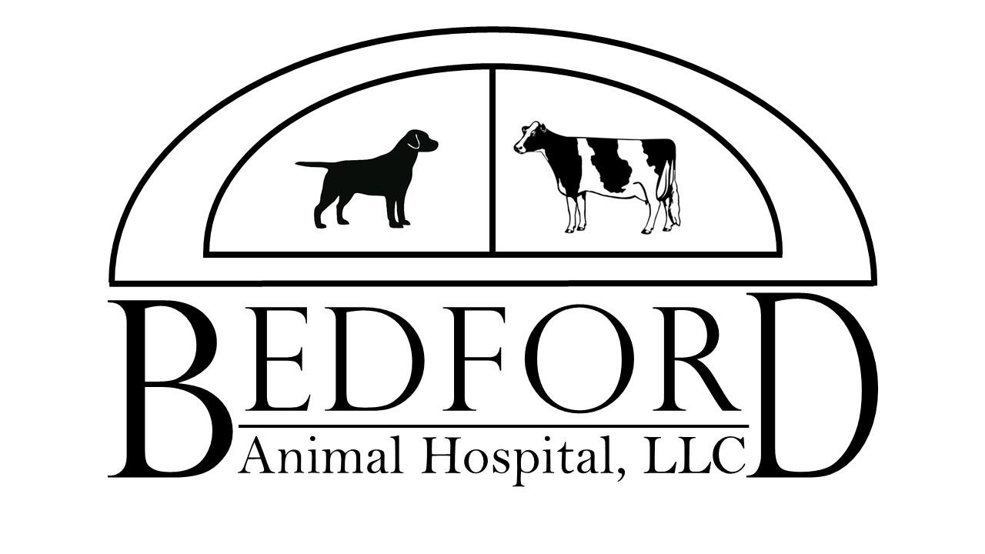

Patient Anesthesia/Surgical Form

Pet Name _____________________________________ Date ___________________________

Welcome to Bedford Animal Hospital! Your pet is here to have the following surgical procedure:

During normal surgical procedures, we routinely clip nails, clean ears and extract retained deciduous (baby) teeth at NO ADDITIONAL CHARGE!!

Is your pet current on their vaccinations? YES NO

Would you like your pet’s vaccinations updated while here? YES NO

If so, which vaccines? _____________________________________________________________

Pre-anesthetic blood work is helpful in determining your pet’s ability to undergo anesthesia. This is important in patients with concurrent disease or in patients over the age of 8 years.
Would you like bloodwork done today?

YES IF VET ADVISES NO/DECLINE

IV Fluids given during an anesthetic procedure or surgery help to maintain blood pressure and allow rapid administration of drugs, should an unexpected emergency arise. We reserve the right to place an IV catheter and administer fluids if your pet is elderly, ill or a veterinarian deems it necessary. This is included in the cost of the procedure.

I hereby authorize Bedford Animal Hospital staff to perform the procedure noted above and to administer anesthetic or other drugs as deemed advisable for my pet. I authorize Bedford Animal Hospital to provide appropriate care should an unexpected complication arise.

I understand the nature of the procedure and the risks involved.

Signature of owner/responsible party: ________________________________________________

Phone number(s) that you can be reached at today: _____________________________________

